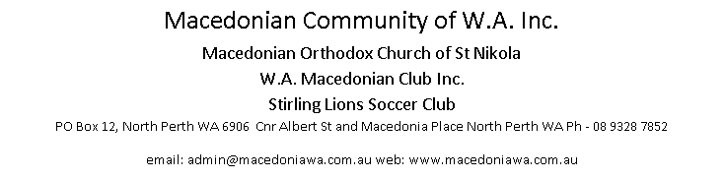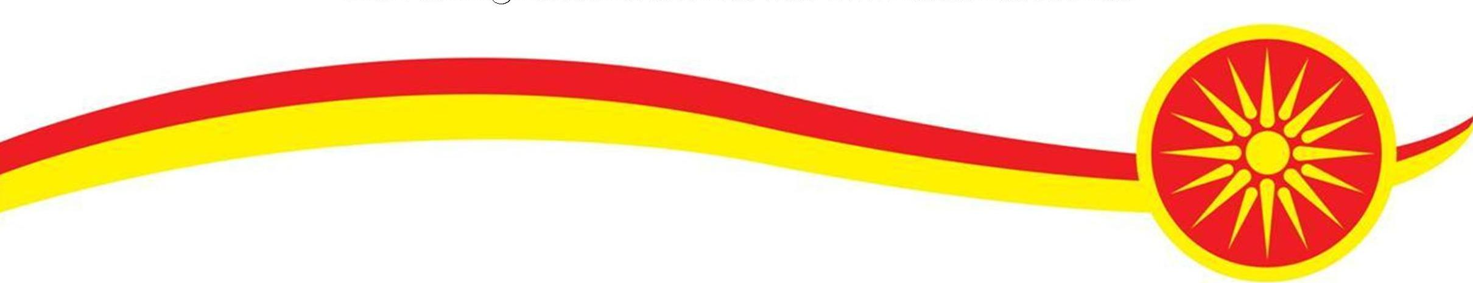
APPLICATION FOR MEMBERSHIP

Please accept my application to become an Ordinary member of the Macedonian Community of W.A. Inc. If accepted I agree to be bound by the Community’s rules and by-laws. I submit an annual subscription fee of $40, and a once only nomination fee of $200.

Name: Date of Birth: Birth Town:
Address:
Spouse Name: Children:
Occupation:
Mobile Phone: Home Phone: Work Phone:
Email: Signature: Date:
Contact preferences (tick): ☐ Postal Mail ☐ Mobile ☐ Email ☐ Home Phone
As current financial members, we support the above candidate’s application and consider that they are in every respect eligible and fit for membership of the Macedonian Community of W.A. Inc.
Proposer (name in full): Membership #:
Signature: Contact Phone:
Seconder (name in full): Membership #:
Signature: Contact Phone:

Post to: The Secretary, Macedonian Community of W.A. Inc, PO Box 12, North Perth WA 6906, with cheque payable to “Macedonian Community of WA”
Or email to: admin@macedoniawa.com.au and Electronic Funds Transfer of fees to
MCWA, BSB 633-000 Account #: 154460760, quoting the reference “New+your Surname”
Office Use Only
Date Received: Date considered by the Management Committee:

Refer to Constitution, available from the Manager in the North Perth premises.
The nomination fee is waived if the candidate is a spouse, child or grandchild of an existing or past Full member who has been financial for 5 or more years. In this case a Seconder is not necessary.

